A Mini Project Report

on

**STAY FIT - A WEB APPLICATION WHICH TRACKS YOUR FITNESS**

By

**A.V.L.Likhita**

**(1602-18-733-058)**

**D.SaiHashitha**

**(1602-18-733-041)**



**Department of Computer Science & Engineering**

**Vasavi College of Engineering (Autonomous)**

**(Affiliated to Osmania University)**

**Ibrahimbagh, Hyderabad-31**

**2020-21**

**ACKNOWLEDGEMENT**

We would like to express our heartfelt gratitude to Mr. Sashi Kumar,(Department of CSE) our project guide, for his valuable guidance and constant support, along with her capable instruction and persistent encouragement.

We are grateful to our Head of Department, Dr T. ADILAKSHMI, for her steady support and the provision of every resource required for the completion of this project.

We would like to take this opportunity to thank our Principal, Dr S. V. RAMANA, as well as the management of the institute, for having designed an excellent learning atmosphere.

**TABLE OF CONTENTS**

List of Tables.................................................................................................................4

List of Figures................................................................................................................5

1. STAY FIT………………………………………………………………..................9

1.1 Introduction………………………………………………………………..9

1.2 Motivation………………………………………………………………..10

1.3 Objective…………………………………………………………………10

1.4 Product Scope………………………………………………………........10

2. Features………………………………………………………………....................11

2.1 Exercise portal ………………………………………………..................11

2.2 Recommendation’s portal …………………………………….................11

2.3 Admin portal ………………………………………………….................11

3. Literature Survey………………………………………………………………….12

4. Software Requirement Specification……………………………………………...14

4.1 Definitions, Acronyms and Abbreviations……………………………....14

4.2 Overall Description…………………………………………………........14

4.3 Other Non-functional Requirements……………………………..............17

5. System Architecture………………………………………………………………12

5.1 Schema Diagram……………………………………………………........19

5.2 Database Tables…………………………………………………….........19

5.3 Unified Modelling Language (UML) Diagram………………….............24

6. Sample Code……………………………………………………………………....27

7. Results……………………………………………………………………………..31

7.1 Exercise Portal………………………………………………...………....34

7.2 Recommendations portal………………………………………. …….....39

7.3 Admin portal…………………………………………………………......47

7.4 Payment Gateway……………………………………………………… .52

8. System Testing…………………………………………………………………….54

9. Conclusion and Future Scope……………………………………………………..55

10. References…………………………………………………………….................56

**LIST OF TABLES**

**TABLE NO TABLE NAME PAGE NO**

1 Admintable 19

2 User_rc 19

3 Food table 20

4 Workouts table 20

5 Tutorials 21

6 Plans 21

7 Feedback 22

8 Chatbot_hints 22

**LIST OF FIGURES**

|  |  |
| --- | --- |
| **Figure No.** | **Figure Name** |
| 1 | Database Schema |
| 2 | Home Page flow diagram |
| 3 | Recommendations Portal flow diagram |
| 4 | Exercise portal flow diagram |
| 5 | Admin module flow diagram |
| 6 | Home page |
| 7 | Features |
| 8 | Reviews |
| 9 | About |
| 10 | Follow us page |
| 11 | Contact page |
| 12 | Exercise Portal(Home Page) |
| 13 | Bar Graphs |
| 14 | Select exercise modal |
| 15 | Add new set of exercise |
| 16 | Count |
| 17 | Shows the day of workout |
| 18 | Bar graphs of sets,reps |
| 19 | List of all workouts |
| 20 | Representation of muscles |
| 21 | Selection of metrics |
| 22 | Go to recommendation page |
| 23 | User registration and login page |
| 24 | Selection of subscription plans(After registration) |
| 25 | After successful login |
| 26 | Basic plan tutorials |
| 27 | Youtube modal for workout tutorials |
| 28 | Standard plan home page |
| 29 | Premium plan home page |
| 30 | Workout recommendations home page |
| 31 | Food recommendations home page |
| 32 | Selection of workout recommendations |
| 33 | Select through category |
| 34 | Display all workout recommendations |
| 35 | How to do a specific workout(GIF File) |
| 36 | Selection of food recommendations |
| 37 | Select through category |
| 38 | Display all food recommendations |
| 39 | Chatbot |
| 40 | Feedback form |
| 41 | Review of some of our users |
| 42 | Navigation to admin portal |
| 43 | Admin login page |
| 44 | Login successful dialog box |
| 45 | Admin Dashboard |
| 46 | Add workouts dialog box |
| 47 | Add food dialog box |
| 48 | Add tutorials |
| 49 | Add a new subscription plan |
| 50 | List of all workout |
| 51 | List of all food items available in the database |
| 52 | List of tutorials |
| 53 | Available subscription plans other than basic ones |
| 54 | User’s details |
| 55 | User’s feedback |
| 56 | Payment gateway(paypal) |
| 57 | Cart (plans) |
| 58 | Payment successful |

**1. STAY FIT**

**1.1 Introduction**

Stay Fitis a web application for analysing and logging strength training and body building data.Stay Fit has two different portals i.e., exercise portal and recommendations portal. Apart from this, it also includes an admin portal.

Exercise portal aims to present workout data in a way that highlights and encourages [progressive overload](https://en.wikipedia.org/wiki/Progressive_overload) and long-term commitment. There are many workout tracking apps already available, what sets this one apart is the focus on data. If you want a workout application that guides you through a routine this is not the tool for you. Exercise portal has no server and works completely offline using [Indexed DB](https://developer.mozilla.org/en-US/docs/Web/API/IndexedDB_API).



On the other hand, if you manage the routine yourself and track your workouts in a spreadsheet with a bunch of formulas and charts, you are probably the kind of person who would like this application.

Recommendations portal provides 3 different subscription plans (Basic, Standard, Premium) where the user can choose their plan according to their requirement. These plans provide basic workout tutorials, workout recommendations and food recommendations according to the user’s weight.

These plans recommend a particular type of workout according to his/her weight and the same follows with food recommendations i.e., for Breakfast, Lunch and Dinner based on the calorie intake.

**1.2 Motivation**

Statistics have shown that the fitness apps influence the gym athletes a lot, these give them motivation to work out a lot and compare it with their friends and family. So such websites have a lot of scope for people who tend to set their goals daily and workout and diet is as important as the workout you do. Many people don’t really know how to have a balanced diet and it becomes very difficult for the people to reach their goal.

Hence, building such a web application would be very useful and can get many real time users.

**1.3 Objective**

This STAY FIT is a web application intended to provide a complete solution for the users. It will enable users to create an account and add their workouts for a particular day and check the progress of their workouts. They can also download their list of workouts at the end of the day. Workouts are broken down into sets of exercises.

Each set is associated with *exactly one* exercise. Each set is performed at one specific weight. Each set consists of one or more reps (repetitions) of an exercise at that weight. Not all exercises are based on lifting weight for certain reps. Some are time-based, but they are still grouped into sets.

The main objective of this recommendation’s portal is to make it easy for the users to choose a perfect diet and proper workouts. It provides 3 different subscription plans (Basic, Standard, Premium) where the user can choose their plan according to their requirement. These plans provide basic workout tutorials, workout recommendations and food recommendations according to the user’s weight.

**1.4 Product Scope**

The purpose of this web application is to ease tracking of the fitness of a particular user and to create a platform for the users who want to keep track of their fitness and diet. So, it has two phases i.e., portals one is exercise portal and another one is recommendations portal. In the exercises portal the users can add their workouts each day and keep track of which muscles they worked on; it also helps you to compare your day-to-day progress. In the recommendation’s portal, the user can get the workout recommendations and diet to be followed based on his/her weight.

Meet all the objectives and implementation of all the modules in a planned way.

**2. FEATURES**

**2.1 Exercise portal**

1. Simple workout data entry supporting reps, sets, weight, duration, warmup and failure sets
2. Exercise Search
3. Supports multiple workouts per day
4. Track and visualise personal records
5. Lots of Charts
6. Musculature visualizations (using SVG files)
7. Intensity and volume calculations
8. Import from CSV
9. Export to JSON
10. Proper time zone support (important for people who travel)
11. Workouts portal works offline, *no network connection required*

**2.2 Recommendation’s portal**

1. Provides different subscription plans for users (Basic, Standard, Premium) etc., paid through payment gateway (Integrated PayPal).
2. Basic plan provides workout tutorials
3. Standard plan provides workout recommendations including features of basic plan.
4. Premium plan includes food recommendations including features of standard
5. A chatbot for conducting an online chat conversation via text.

**2.3 Admin portal**

1. Admin portal for providing recommendations on daily basis.
2. Dashboard
3. Perform certain actions like insertion, deletion and updating.
4. Workout and food recommendations, tutorials.

**3. LITERATURE SURVEY**

Healthy eating and fitness web applications like STAY FIT are designed to promote healthier living. However, for young people, body dissatisfaction is commonplace, and these types of web applications/apps can become a source of maladaptive eating and exercise behaviours. Furthermore, such applications are designed to promote continuous engagement, potentially fostering compulsive behaviours.

As our project has two phases the first one is workouts progress and the second one being recommendations part (both food i.e., a proper diet plan and workouts). We looked at researches on both the scenarios.

<https://www.ncbi.nlm.nih.gov/pmc/articles/PMC6604512/>

The above research given was conducted in two phases. Through a survey and 2 workshops, this paper contains information on understanding of young people’s perceptions of healthy eating and fitness apps and any potential harm that their use might have and also explored these further through interviews with experts in eating disorder and body image. Using insights drawn from this initial phase. This paper also have a review of the top 100 healthy eating and fitness apps on the Google Play Store to find out whether or not apps on the market have the potential to elicit maladaptive eating and exercise behaviours.

The results of this paper shows that participants were aged between 18 and 25 years and had current or past experience of using healthy eating and fitness apps. Almost half of our survey participants indicated that they had experienced some form of negative experiences and behaviours through their app use. The app review identified logging functionalities available across the apps that are used to promote the sustained use of the app. However, a significant number of these functionalities were seen to have the potential to cause negative experiences and behaviours. This paper highlights necessity for careful considerations around the design of apps that promote weight loss or body modification through fitness training and provide a proper diet, especially when they are used by young people who are vulnerable to the development of poor body image and maladaptive eating and exercise behaviours.

**4. SOFTWARE REQUIREMENT SPECIFICATION**

**4.1 Definitions, Acronyms and Abbreviations**

SQL -> Structured Query Language

ERD -> Entity Relationship Diagram

UML -> Unified Modelling Language

SRS -> Software Requirement Specification

DFD -> Data Flow Diagram

**4.2 Overall Descriptions**

**4.2.1User Classes and Characteristics**

The portal displays data based on user entitlements. Here userscan have accessto both exercise and recommendation’s portal. Specific subscription plan to be selected for recommendation’s portal. User can get few graphs along with duration time, intensity, and volume calculations. Other than these, users can do the following

* Look at the features in the home page
* Users can sign up if they are using Stayfit for the first time. Regular users can just login.
* Users can view muscular visualisations
* Users can view duration time, intensity, and volume calculations in form of graphs.
* Users can select from different subscription plans and pay using paypal gateway.
* Users can use the users friendly chat application for clarifying user’s doubts.
* Admin can make changes regularly.
* Admin can add/delete/update recommendations and plans.
* Admin can view the list of users and their feedbacks.
* Admin can delete users if they use the website in the wrong way or delete users if they try to post malicious content.

**4.2.2 Operating Environment**

This application will be operating in webpages through browser. This web application can be operated through any browser supporting java script. The only requirement to use this website would be an internet connection and a device which has access toa browser which supports java script and Indexed DB.

**4.2.3 Assumptions and Dependencies**

The assumptions are:

* The coding should be error free.
* The application should be user-friendly so that it is easy to use.
* Valid information of every user must be stored in database.
* The system should provide more storage capacity and provide fast access to the database.
* The sever running 24 hours a day.
* Users may access from any browser that has Internet browsing capabilities and supports java script and Indexed DB.

The dependencies are:

* The specific hardware and software due to which the product will be run.
* Based on listing requirements and specification the project will be developed and run.
* The end users should have proper understanding of the product.
* The information of all the users must be stored in a database that is accessible by the college campus system.
* Any update regarding the user profile and any other updation is to be recorded to the database and the data entered should be recorded.

**4.2.4 Requirements**

**4.2.4.1 Software Requirements**

**Front-end:**HTML 5

*HTML 5*

**HTML5** is a [markup language](https://en.wikipedia.org/wiki/Markup_language) used for structuring and presenting content on the [World Wide Web](https://en.wikipedia.org/wiki/World_Wide_Web). It is the fifth and last major [HTML](https://en.wikipedia.org/wiki/HTML) version that is a [World Wide Web Consortium (W3C)](https://en.wikipedia.org/wiki/World_Wide_Web_Consortium) recommendation.

*jQuery*

**jQuery** is a JavaScript library designed to simplify HTML DOM tree traversal and manipulation, as well as event handling, CSS animation, and Ajax.

*Javascript (for validations)*

**JavaScript**(often shortened to **JS**) is a lightweight, interpreted, object-oriented language with first-class functions, and is best known as the scripting language for Web pages, but it's used in many non-browser environments as well.

**Styling:** CSS, Bootstrap

*Bootstrap*

**Bootstrap** is a free and open-source CSS framework directed at responsive, mobile-first front-end web development. It contains CSS- and (optionally) JavaScript-based design templates

**Server-side**: PHP (For server-side connection)

PHP is a server scripting language, and a powerful tool for making dynamic and interactive Web pages.PHP is a widely used, free, and efficient alternative to competitors such as Microsoft's ASP.PHP 7 is the latest stable release.

**Database**: MySQL Database

*MySQL Database*

MySQL is an open-source relational database management system (RDBMS). Its name is a combination of "My", the name of co-founder Michael Wideness’s daughter, and "SQL", the abbreviation for Structured Query Language

**Tools & IDE’s**: Sublime IDE, Xampp for MySQL

**4.2.4.2 Hardware Requirements**

Operating System: Windows 10

Processor: Core i5 Processor

Clock speed: 2.5GHz

Monitor: 1920* 1080 Resolution Colour

Keyboard: QWERTY

RAM: 8 GB

**4.2.5 Data Requirement**

The inputs consist of the query to the database and the output consists of the solutions for the query. The output also includes the user receiving the details of their accounts. In this project the inputs will be queries as fired by the users like create an account. Now the output will be visible when the user requests the server to get details of their profile and all the posts.

**4.3 Other Non-functional Requirements**

**4.3.1 Performance Requirement**

The proposed system that we are going to develop is expected to target huge audience. Therefore, it is expected that the database is functional and can handle all the requests given by the users.

The performance of the system should be fast and accurate.

The System shall handle expected and non-expected errors in a way that prevent loss in information and long downtime period. Thus, it should have inbuilt error testing to identify search or data check/fetch.

The system should be able to handle large amount of data. Thus, it should accommodate large number of requests without any fault.

**4.3.2 Satisfy Requirement**

The database may get crashed at any certain time due to virus or operating system failure. Therefore, it is required to takea database backup.

**4.3.3 Security Requirement**

* System will use secured database.
* Normal users can just read instruction and use this system, but they cannot edit or modify anything except their personal and some other information.
* System will have two type of users and user has access constraints.
* Proper user authentication should be provided.
* No one should be able to hack user’s details or any other information.
* There should be separate part for users that no users can access the database and only admin has the rights to update the database.

**4.3.4 Requirement attributes**

* There may be multiple admins creating the project, all of them will have the right to create changes to the system. But the users cannot do thechanges.
* The project should be open source.
* The quality of the database is maintained in such a way so that it can be very user friendly to all the users of the database.
* The user be able to easily access this system from anywhere at any time.

**4.3.5 Business Rule**

A business rule is anything that captures and implements business policies and practices. A rule can enforce business policy, decide, or infer new data from existing data. This includes the rules and regulations that the System users should abide by. This includes the cost of the project and the discount offers provided. The users should avoid illegal rules and protocols. Neither admin nor member should cross the rules and regulations.

**4.3.6 User Requirement**

The users are assumed to have basic knowledge of the computers and internet browsing. The administrators of the system should have more knowledge of the internals of the system and is able to rectify the small problems that may arise due to disk crashes, power failures and other catastrophes to maintain the system. The proper user interface, user manual, online help, and the guide to install and maintain the system must be sufficient to educate the users on how to use the system without any problems.

**5. SYSTEM ARCHITECTURE**

**5.1 Schema Diagram**

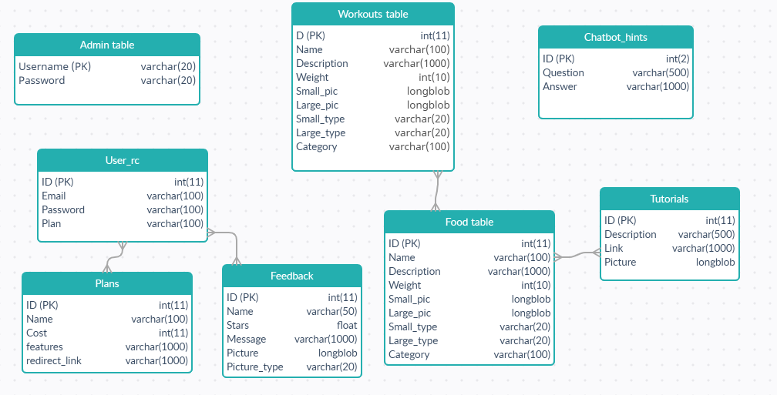

*Fig 1: Database scheme*

**5.2 Database Tables**

**Table 1:** Admintable

|  |  |  |  |
| --- | --- | --- | --- |
| **COLUMN NAME** | **DATATYPE &**  **SIZE** | **CONSTRAINTS** | **DESCRIPTION** |
| Username | Varchar(100) | Primary Key | Username of admin |
| Password | Varchar(20) | Not null | Password of admin |

**Table 2:** User_rc

|  |  |  |  |
| --- | --- | --- | --- |
| **COLUMN NAME** | **DATATYPE &**  **SIZE** | **CONSTRAINTS** | **DESCRIPTION** |
| ID | int(11) | Primary Key | The ID accepts the integer which identify the user |
| Email | varchar(100) | Not null | Email of the user |
| Password | varchar(100) | Not null | Password of the user |
| Plan | varchar(100) | Not null | The subscription which the user opted. |

**Table 3:** Food table

|  |  |  |  |
| --- | --- | --- | --- |
| **COLUMN NAME** | **DATATYPE &**  **SIZE** | **CONSTRAINTS** | **DESCRIPTION** |
| ID | int(11) | Primary Key | The ID accepts the integer which identify the food item |
| Name | varchar(100) | Not null | Name of food item |
| Description | varchar(100) | Not null | Description of the food item |
| Weight | int(100) | Not null | Weight of the person who can eat the food item |
| Small_pic | longblob | Not null | Small size pic of food |
| Large_pic | longblob | Not null | Large picture of food item |
| Small_type | varchar(20) | Not null | Type of small picture |
| Large_type | varchar(20) | Not null | Type of large picture |
| category | varchar(100) | Not null | Category of food item |

**Table 4:** Workouts table

|  |  |  |  |
| --- | --- | --- | --- |
| **COLUMN NAME** | **DATATYPE &**  **SIZE** | **CONSTRAINTS** | **DESCRIPTION** |
| id | int(11) | Primary Key | The ID accepts the integer which identify the workout |
| name | varchar(100) | Not null | Name of the workout |
| description | varchar(100) | Not null | Description of the workout |
| weight | int(100) | Not null | Weight of the person who can perform the workout |
| small_pic | longblob | Not null | Small size pic of workout |
| large_pic | longblob | Not null | Large picture of workout |
| small_type | varchar(20) | Not null | Type of small picture |
| large_type | varchar(20) | Not null | Type of large picture |
| category | varchar(100) | Not null | Category of workout |

**Table 5:** Tutorials

|  |  |  |  |
| --- | --- | --- | --- |
| **COLUMN NAME** | **DATATYPE &**  **SIZE** | **CONSTRAINTS** | **DESCRIPTION** |
| ID | int(11) | Primary Key | The ID accepts the integer which identify a specific tutorial |
| Description | varchar(500) | Not Null | Short note of youtube video |
| Link | varchar(10000) | Not Null | iframe link from youtube |
| Picture | Longblob | Not Null | Sample picture for youtube video |
| Picture_type | varchar(25) | Not Null | Type of picture |

**Table 6:** Plans

|  |  |  |  |
| --- | --- | --- | --- |
| **COLUMN NAME** | **DATATYPE &**  **SIZE** | **CONSTRAINTS** | **DESCRIPTION** |
| ID | int(11) | Primary Key | The ID accepts the integer which identify a specific plan |
| Name | varchar(100) | Not Null | Name of the subscription plan |
| Cost | int(11) | Not Null | Price of the subscription plan |
| Features | varchar(1000) | Not Null | Features related to the plan |
| Redirect_link | varchar(1000) | Not Null | Home page of specific plan |

**Table 7:** Feedback

|  |  |  |  |
| --- | --- | --- | --- |
| **COLUMN NAME** | **DATATYPE &**  **SIZE** | **CONSTRAINTS** | **DESCRIPTION** |
| ID | int(11) | Primary Key | The ID accepts the integer which identify a specific plan |
| Name | varchar(10) | Not null | Name of the user who have given feedback |
| Stars | float | Not null | Number of stars |
| Message | varchar(1000) | Not null | Feedback given by the user |
| Picture | longblob | Null | Profile picture of the user |
| Picture_type | varchar(20) | Not null | Type of picture(jpg/png) |

**Table 8:** Chatbot_hints

|  |  |  |  |
| --- | --- | --- | --- |
| **COLUMN NAME** | **DATATYPE &**  **SIZE** | **CONSTRAINTS** | **DESCRIPTION** |
| id | int(2) | Primary Key | The ID accepts the integer which identify chatbot question and answers |
| question | varchar(500) | Not null | Questions related to fitness and diet |
| reply | varchar(1000) | Not null | replies to the respective questions |

**Indexed DB:**

Key: id

Value: all other metrics

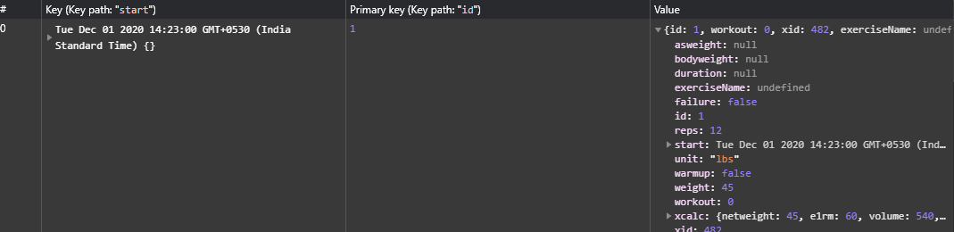

*Fig 2: Indexed DB*

**5.3 Unified Modelling Language (UML) Diagram**

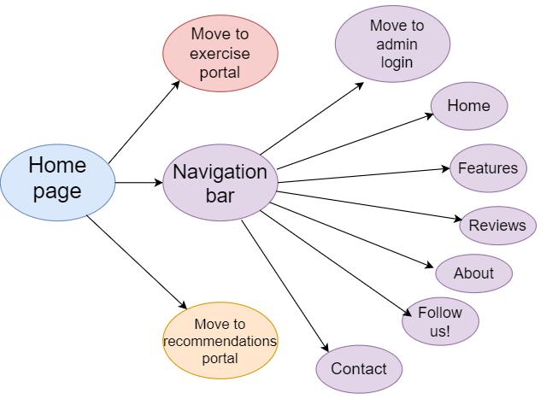

*Fig 3: Home page*

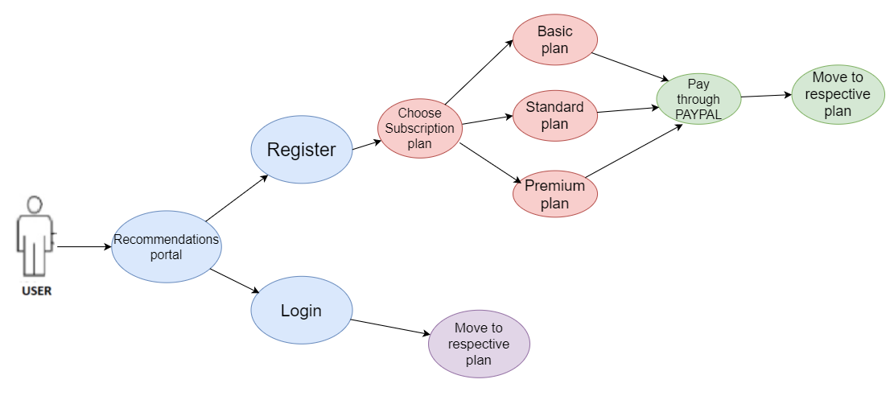

*Fig 4: Recommendations portal*

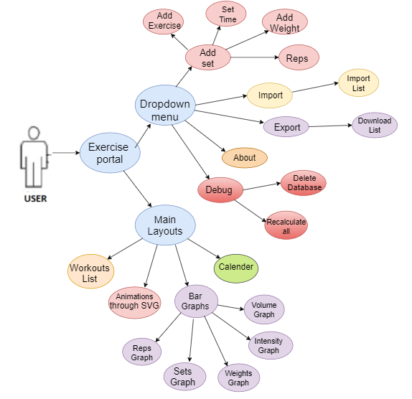

*Fig 5: Exercise Portal*

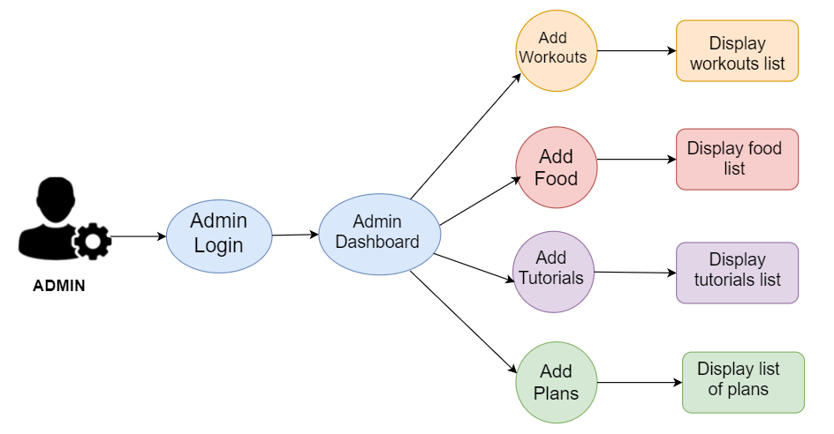

*Fig 6: Admin portal*

**6. CODE IMPLEMENTATION**

**Link for github repository:** <https://github.com/likhitaavl2k/Stay-fit--A-web-application-which-tracks-your-fitness.git>

**Access.html (To choose admin/user)**

<!DOCTYPE html>

<html>

<head>

<title>Admin/User</title>

<link rel="stylesheet" type="text/css" href="css/access.css">

<link rel="stylesheet" type="text/css" href="https://stackpath.bootstrapcdn.com/font-awesome/4.7.0/css/font-awesome.min.css">

</head>

<!-- background-image: url(images/accessbg2.jpg) -->

<header style="position: absolute;top: 1%;">

<a href="index.php"><i class="fa fa-home fa-5x" ></i></a>

</header>

<body style="background-repeat: no-repeat;background-size: cover;">

<div style="padding-left: 300px;padding-top: 100px;" id="admindiv">

<div class="vl" ></div>

<a href="adminLogin.html"><imgsrc="images/female.png" ></a>

<br><br>

<label style="position: absolute;left:27%;font-size: 50px;">ADMIN</label>

</div>

<div style="position: absolute;top: 18%;left: 60%" id="userdiv">

<a href="userlogin.php"><imgsrc="images/user1.png" width="64%"></a>

<br>

<label style="position: absolute;left: 20%;font-size: 50px;">USER</label>

</div>

</body>

</html>

**Open or create Indexed DB @ mb.js**

function loadFromDB() {

console.log("loading db...");

constdbOpen = window.indexedDB.open("myDatabase", 1);

dbOpen.onerror = event => {

alert(event.target.errorCode);};

}

**Add object to Indexed DB @ mb.js**

function calculateE1RM(reps, weight) {

if (reps < 0) throw new Error("invalid reps: %s", reps);

if (reps === 0) return 0;

if (reps == 1) return weight;

if (reps < 10) return Math.round(weight / (1.0278 - 0.0278 * reps));

else return Math.round(weight / 0.75);

}

function calculateEntry(entry) {

entry.xcalc.netweight = calculateNetWeight(entry);

entry.xcalc.e1rm = calculateE1RM(entry.reps, entry.weight);

entry.xcalc.volume = calculateVolume(entry);

}

**Delete all entries from the database @ mb.js**

function deleteAllEntries() {

db.close();

let req = indexedDB.deleteDatabase("myDatabase");

req.onsuccess = function () {

alert("Deleted database successfully");

};

}

**Database connection @database.inc.php**

<?php

$con=mysqli_connect('localhost','root','','admindb');

?>

**User Registration @ insertuser.php**

if (isset($_POST['signup'])) {

$email = $_POST['email'];

$password = $_POST['password'];

}

$query="SELECT * FROM USERSRC WHERE EMAIL='$email'";

$data=mysqli_query($conn,$query);

$num=mysqli_num_rows($data);

$uppercase = preg_match('@[A-Z]@', $password);

$lowercase = preg_match('@[a-z]@', $password);

$number = preg_match('@[0-9]@', $password);

$hashpassword = md5($password);

$query1="insert into usersrc(email,password) values('$email','$hashpassword')";

$data1=mysqli_query($conn,$query1);

**Delete using ID @ deleteuser,php**

<?php

$id = $_POST['id2'];

echo $id;

$query = "DELETE FROM USERSRC WHERE ID='$id'";

mysqli_query($con,$query);

?>

<META HTTP-EQUIV="Refresh" CONTENT="0; URL=includeusers.php">

**Store weight in cookies @StoreWeightInCookie.php**

<?php

session_start();

$cookie_name = "weight";

$cookie_value = $_POST['Weight'];

setcookie($cookie_name, $cookie_value, time() + (86400 * 30), "/");

echo "<script>location.href='workoutrecom_stand.php'</script>";

?>

**Validation @uservalidate.php**

if (isset($_POST['login'])) {

$email = $_POST['email'];

$password = $_POST['password'];

}

$query="SELECT * FROM USERSRC WHERE EMAIL='$email'";

$data=mysqli_query($conn,$query);

$result=mysqli_fetch_assoc($data);

if(md5($password))!== $result['password']){

echo “success”; }

**Update food details @editfood.php**

if (isset($_POST['id'])) {

$id=$_POST['id1'];

$name=$_POST['name'];

$description=$_POST['description'];

$weight=$_POST['weight'];

$category=$_POST['category'];

$smallfile = addslashes(file_get_contents($_FILES['file1']['tmp_name']));

$largefile = addslashes(file_get_contents($_FILES['file2']['tmp_name']));

$smalltype=$_FILES['file1']['type'];

$largetype=$_FILES['file2']['type'];

}

$query = "UPDATE FOODTABLE SET NAME='$name' ,DESCRIPTION='$description',WEIGHT='$weight',CATEGORY='$category' WHERE ID='$id'";

$set=mysqli_query($con,$query);

if(!empty($smallfile)){

$query1 = "UPDATE FOODTABLE SET SMALL_PIC='$smallfile',SMALL_TYPE='$smalltype' WHERE ID='$id'";

mysqli_query($con,$query1);

}

if(!empty($largefile)){

$query2 = "UPDATE FOODTABLE SET LARGE_PIC='$largefile', LARGE_TYPE='$largetype' WHERE ID='$id'";

mysqli_query($con,$query2); }

**7. RESULTS/SCREENSHOTS**

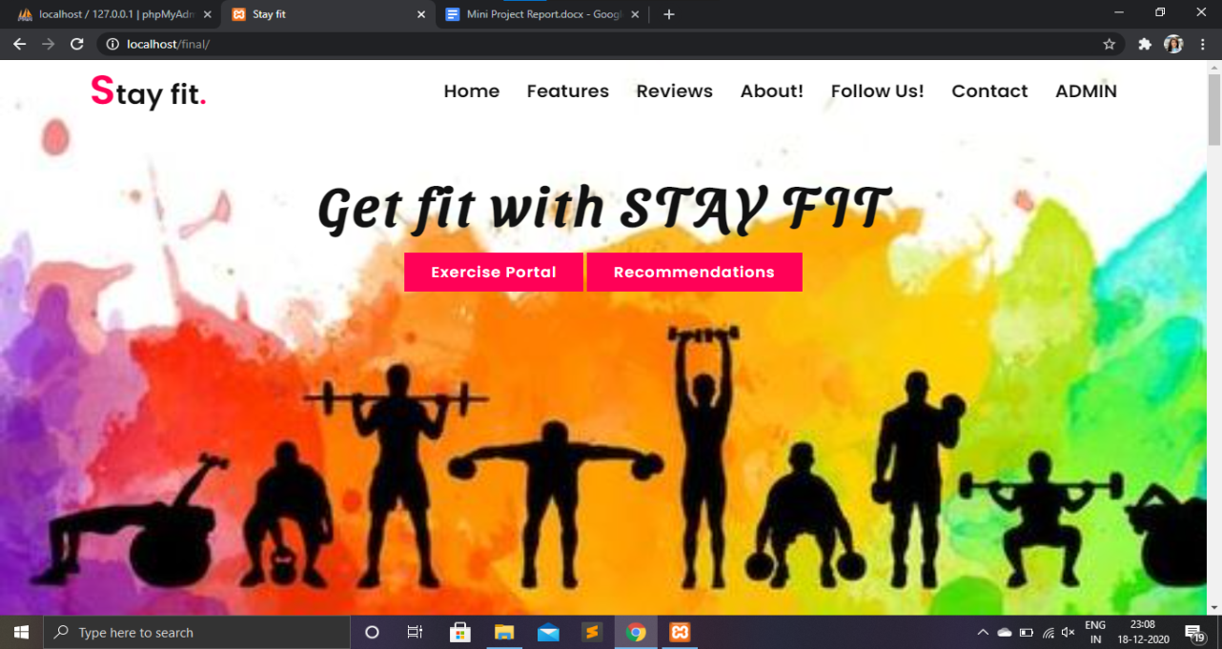

*Fig 7: Home page*

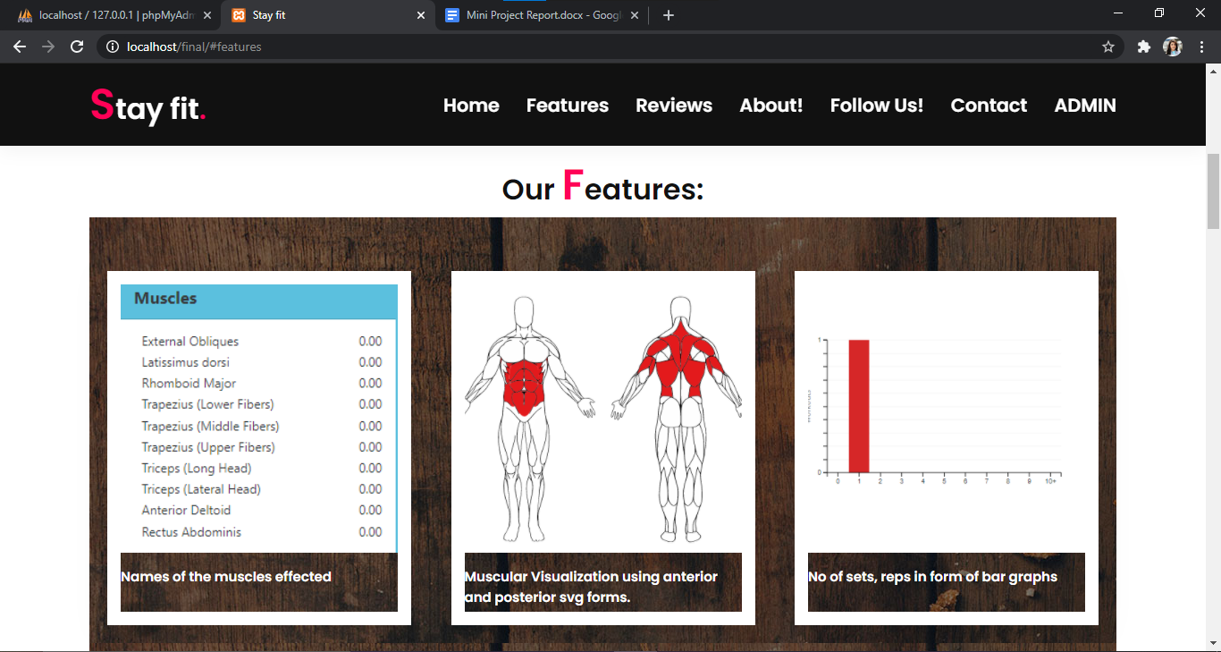

*Fig 8: Features*

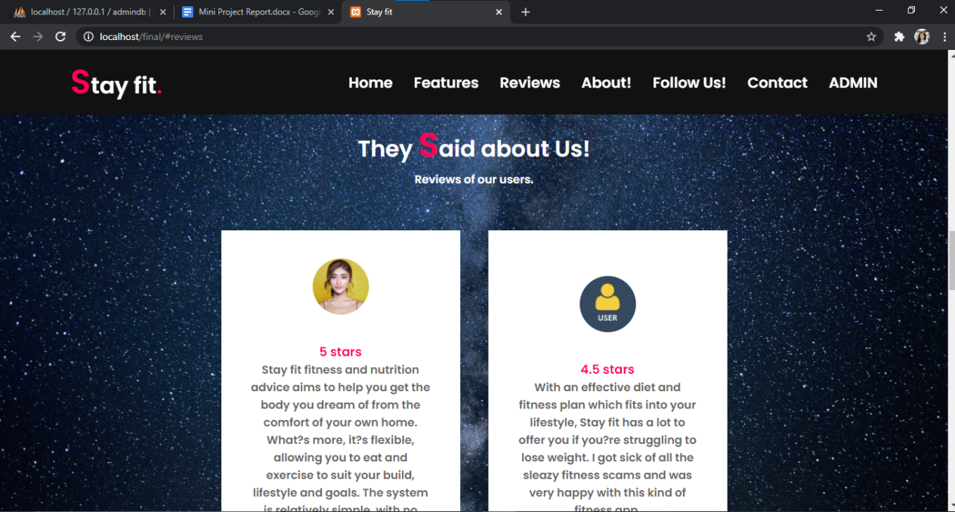

*Fig 9: Reviews*

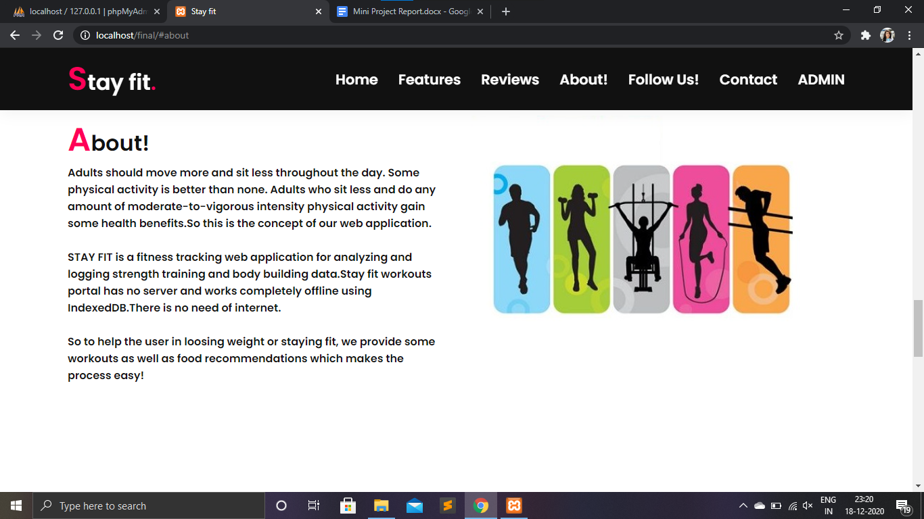

*Fig 10: About*

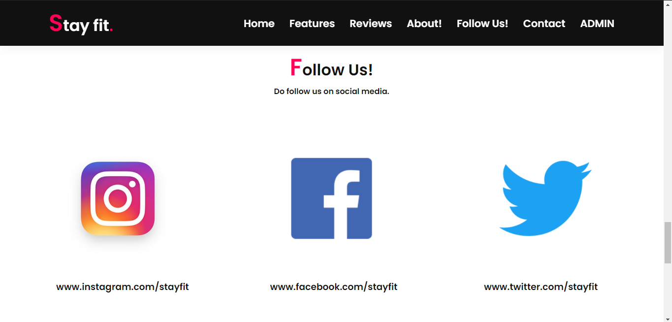

*Fig 11: Follow on social media*

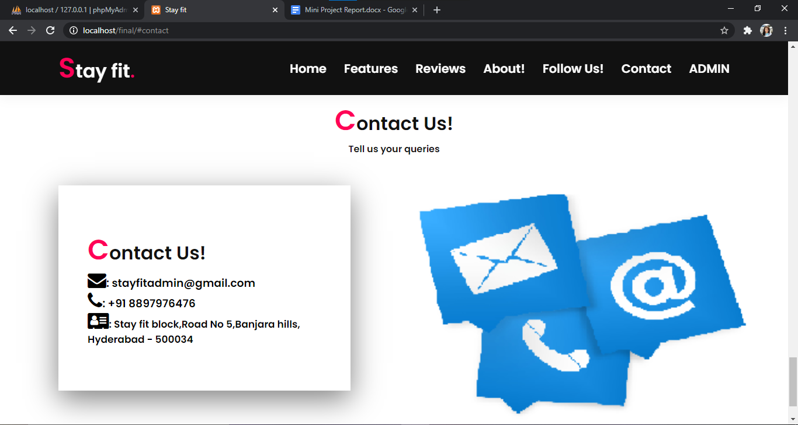

*Fig 12: Contact Us page*

**7.1 Exercise portal:**

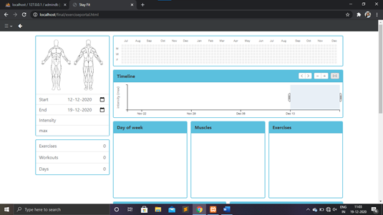

*Fig 13: Exercise portal home page*

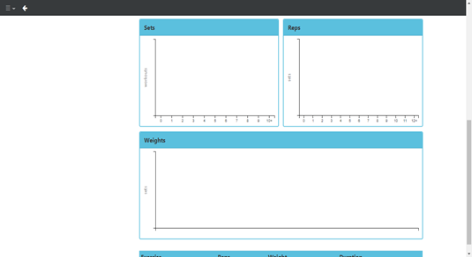

*Fig 14: Bar graphs columns of sets, reps and weight*

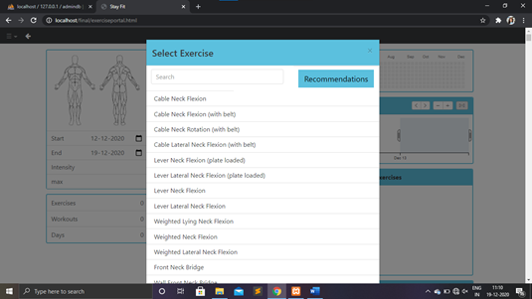

*Fig 15: Select exercise modal*

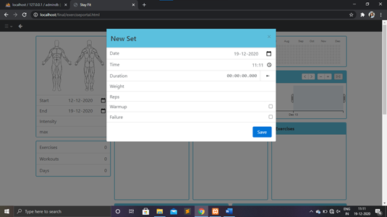

*Fig 16: Add new set of exercise*

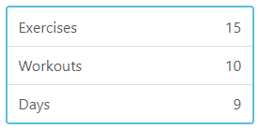

*Fig 17: Count of Exercises, Workouts and Days*

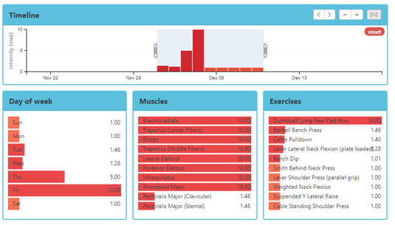

*Fig 18: After performing few sets of exercises (Timeline, Days of week, Muscles and Exercises performed)*

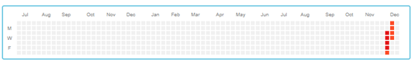

*Fig 19: Shows the days of workout in the calendar*

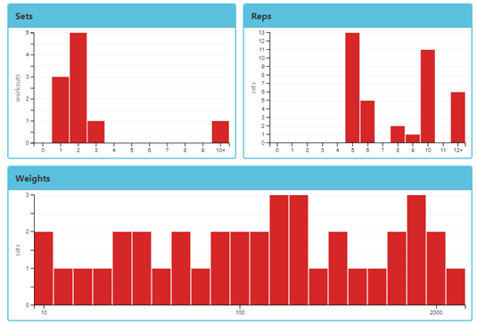

*Fig 20: Bar graphs of sets and reps using dc.js predefined library*

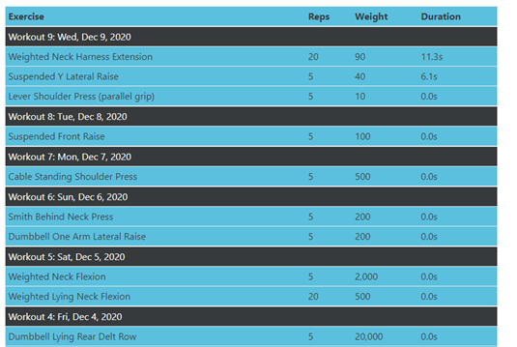

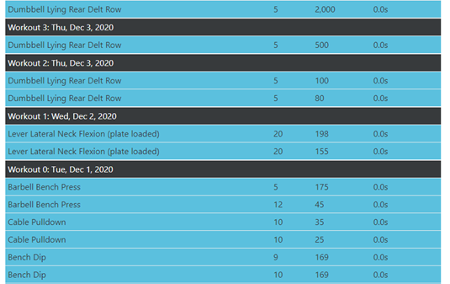

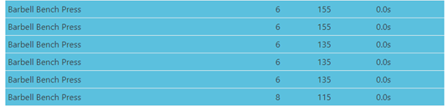

*Fig 21: List of all the workouts in a specific week*

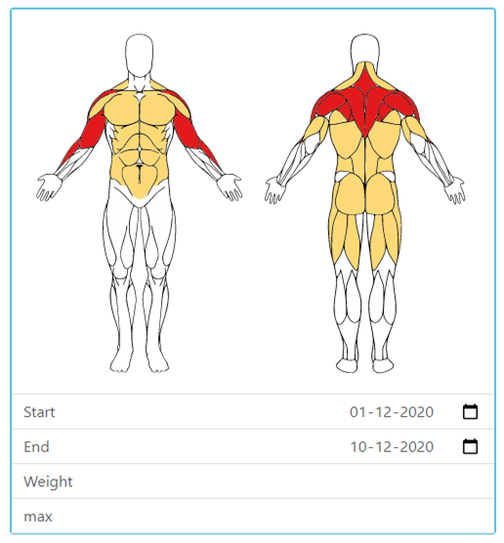

*Fig 22: Representation of muscles affected*

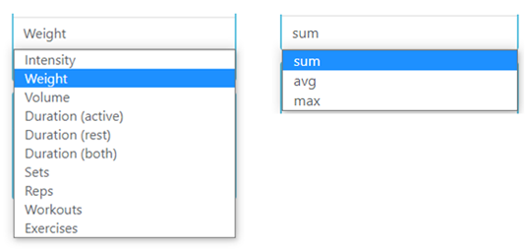

*Fig 23: Dropdown for selection of metrics*

**7.2 Recommendations portal:**

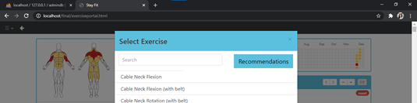

*Fig 24: Navigate to recommendations portal*

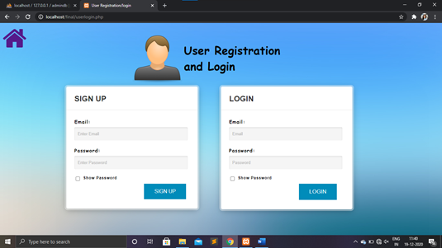

*Fig 25: User Registration and Login page*

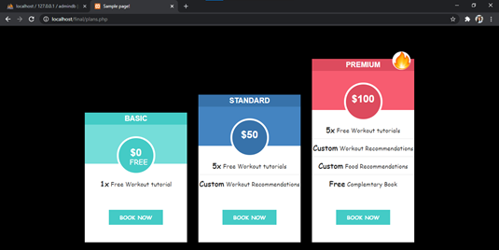

*Fig 26: Selection of subscription plans (After registration)*

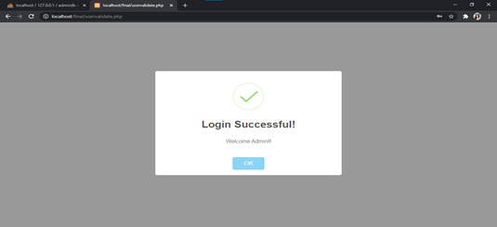

*Fig 27: After successful login*

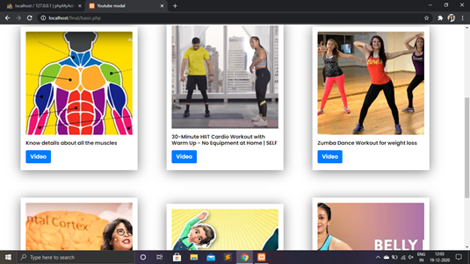

*Fig 28: Basic plan tutorials*

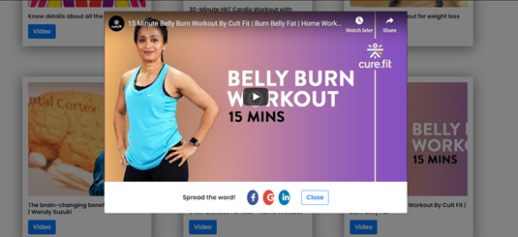

*Fig 29: Youtube modal for workout tutorials*

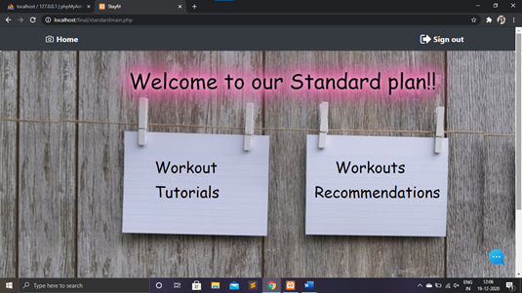

*Fig 30: Standard plan home page*

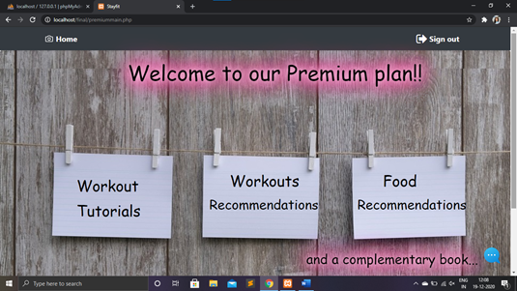

*Fig 31: Premium plan home page*

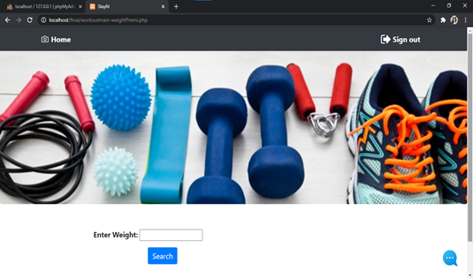

*Fig 32: Workout recommendations home page*

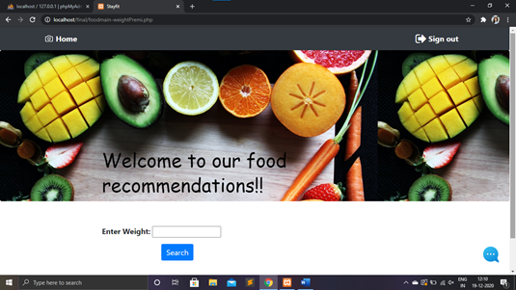

*Fig 33: Food recommendations home page*

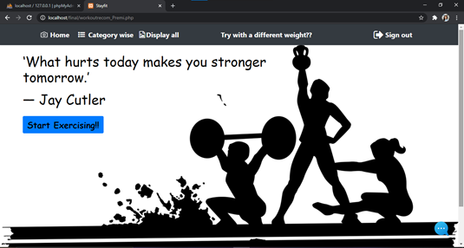

*Fig 34: Selection of workout recommendations*

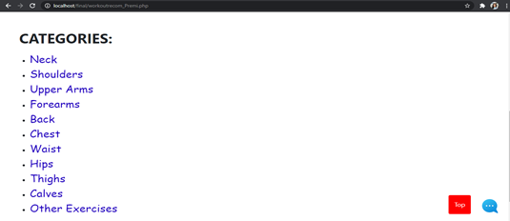

*Fig 35: Selection through category*

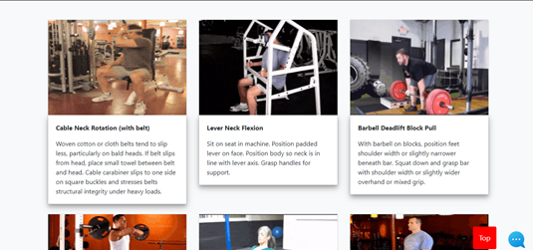

*Fig 36: Display all workout recommendations*

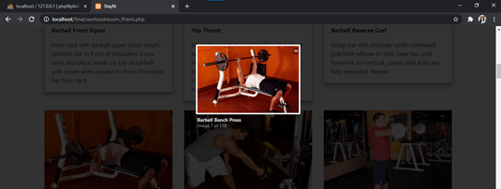

*Fig 37: How to do a specific workout? (GIF File)*

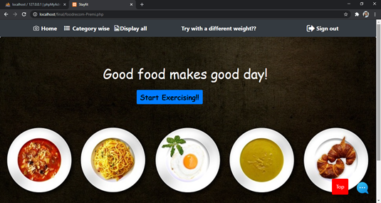

*Fig 38: Selection of food recommendations*

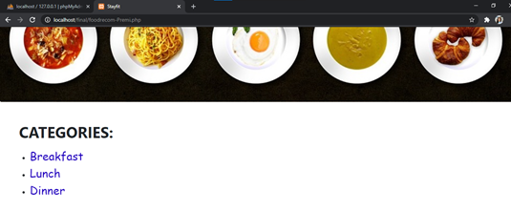

*Fig 39: Selection through category*

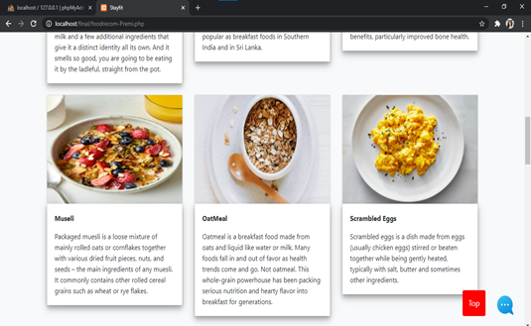

*Fig 40: Display all food recommendations*

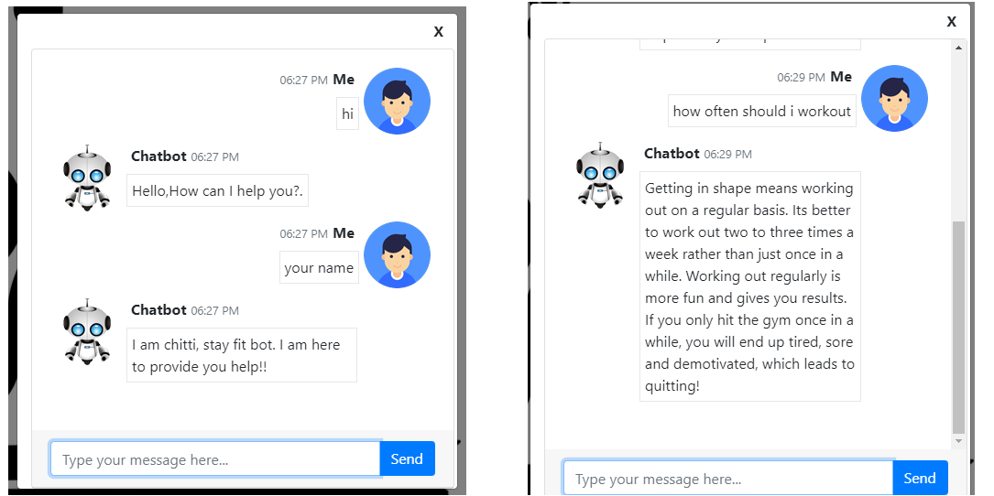

*Fig 41: Chatbot*

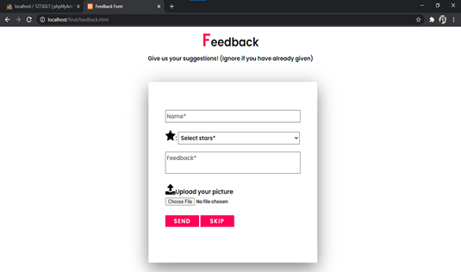

*Fig 42: Feedback form*



*Fig 43: Review of some of our users*

**7.3 Admin portal:**

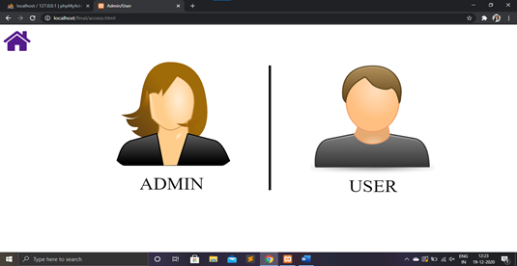

*Fig 44: Navigation to admin portal*

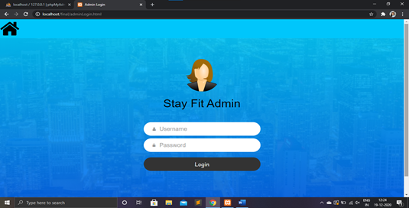

*Fig 45: Admin login page*

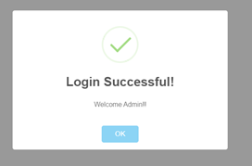

*Fig 46: Login successful dialog box*

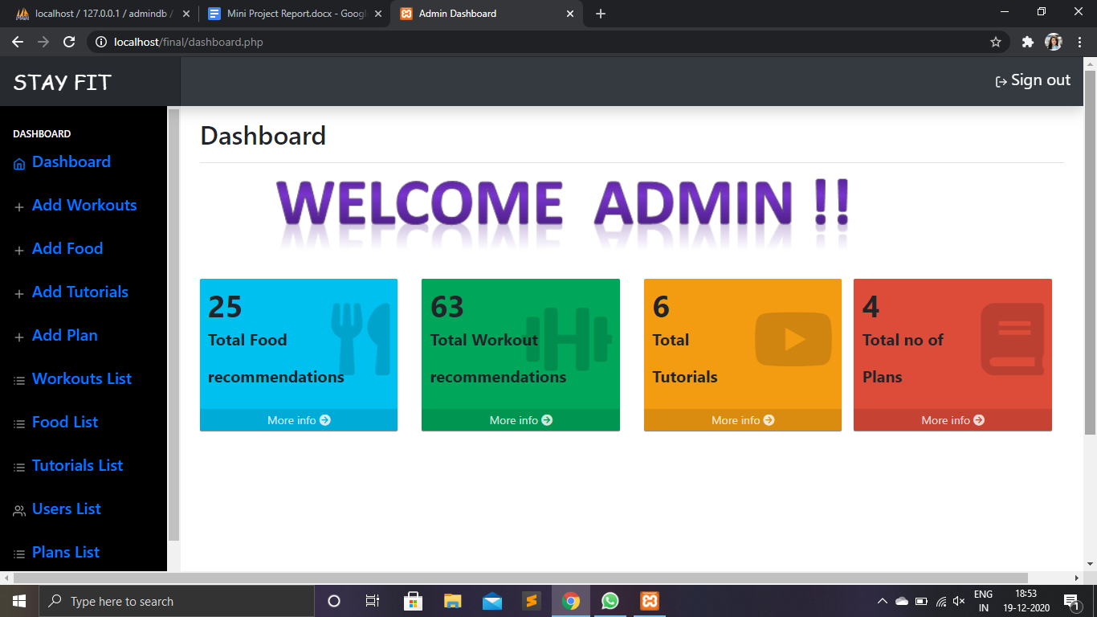

*Fig 47: Admin Dashboard*

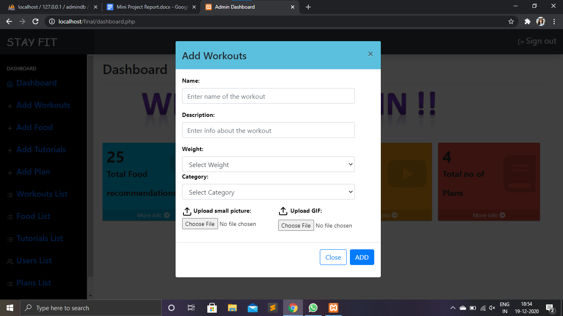

*Fig 48: Add Workouts dialog box*

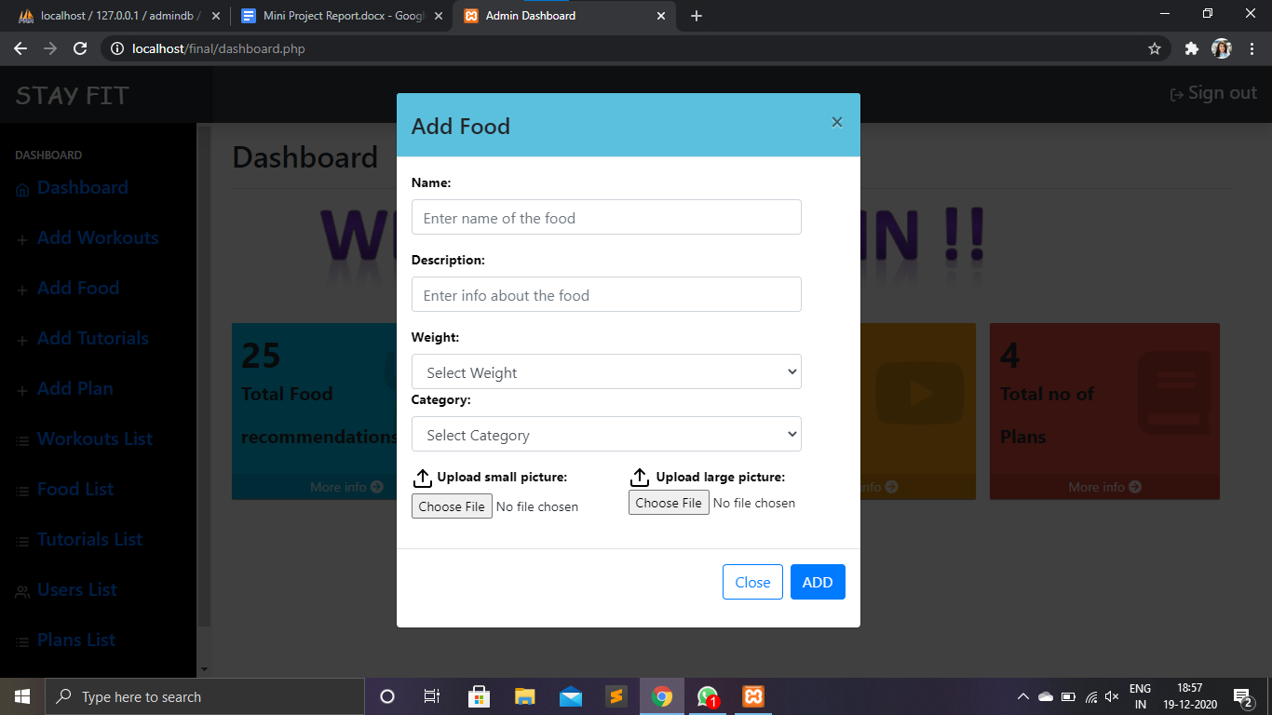

*Fig 49: Add food dialog box*

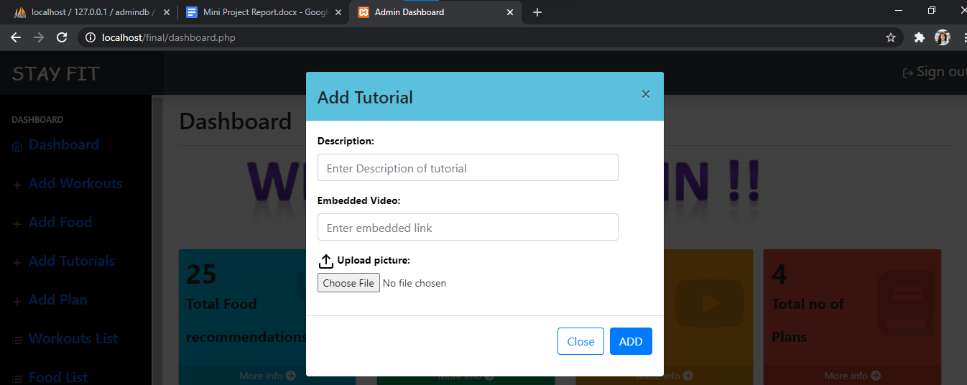

*Fig 50: Add tutorials*

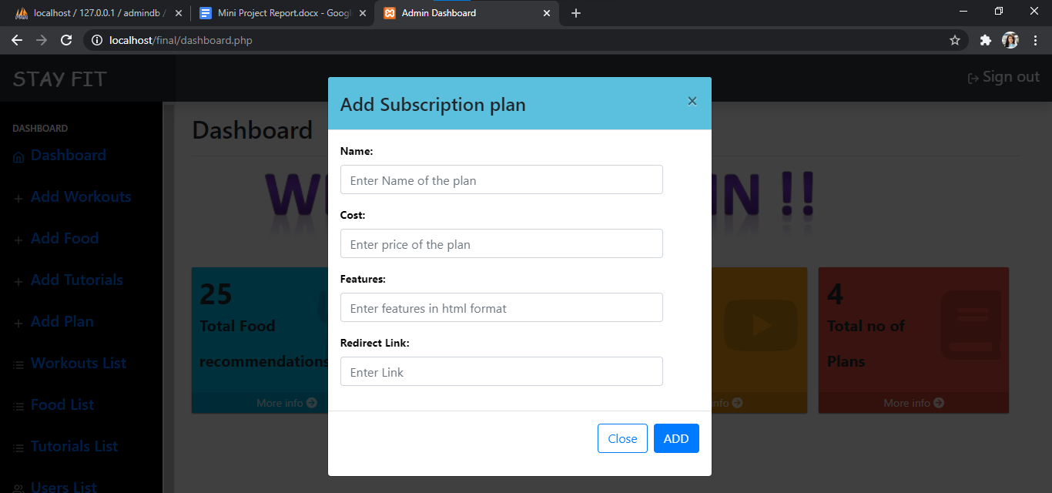

*Fig 51: Add a new subscription plan*

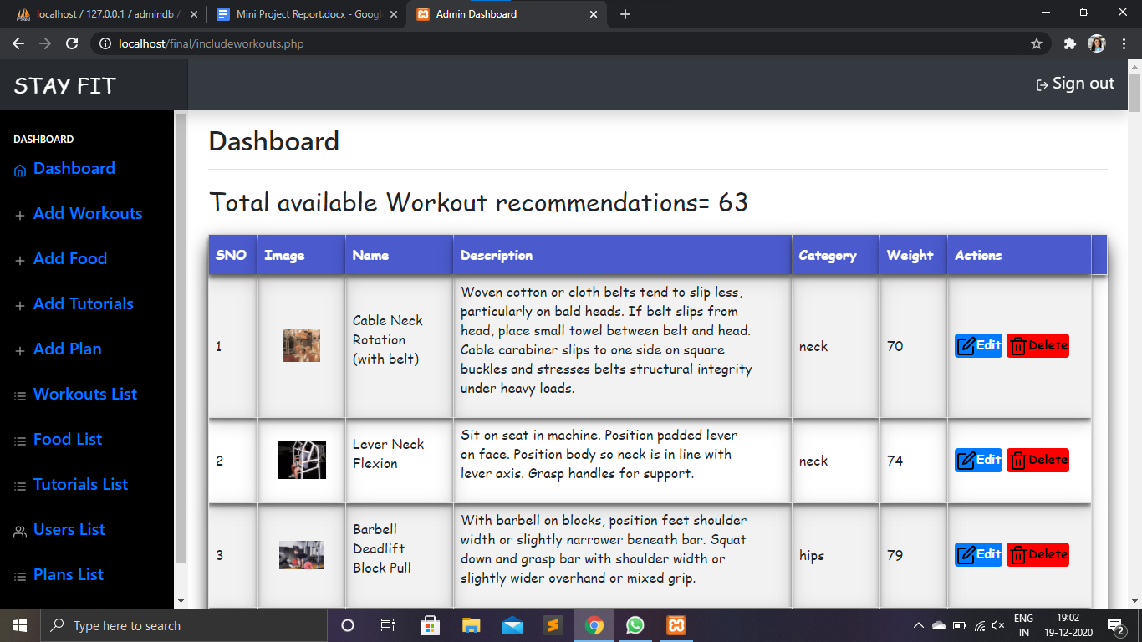

*Fig 52: List of all the workouts*

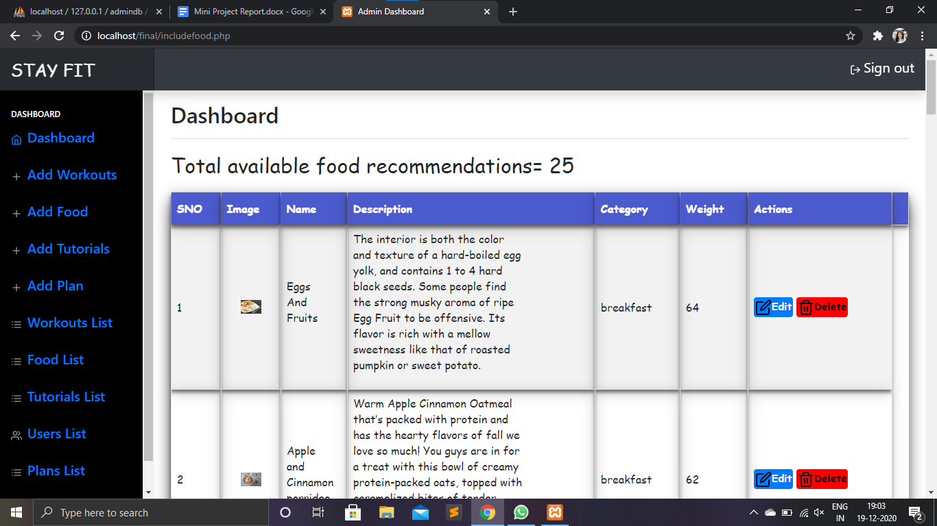

*Fig 53: List of all food items available in the database*

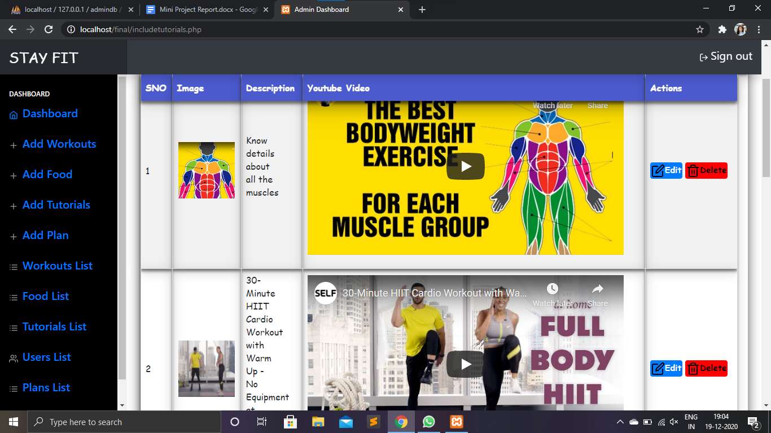

*Fig 54: List of tutorials*

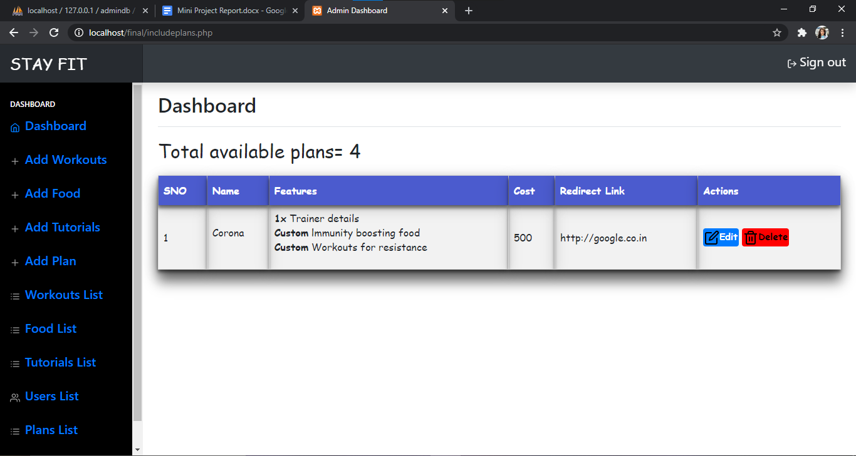

*Fig 55: Available subscription plans other than basic ones*

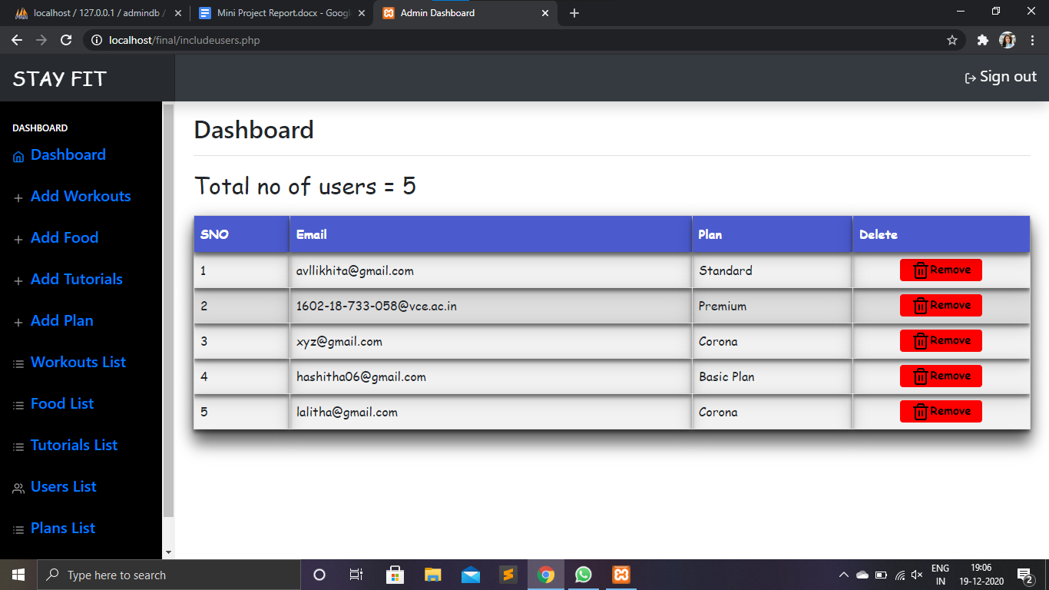

*Fig 56: User’s details*

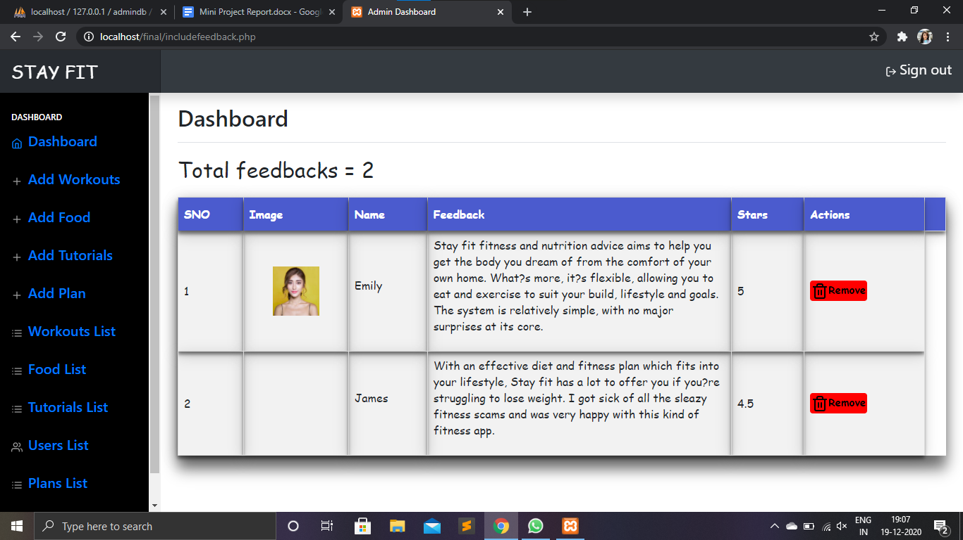

*Fig 57: Users feedback*

**7.4 Payment Gateway**

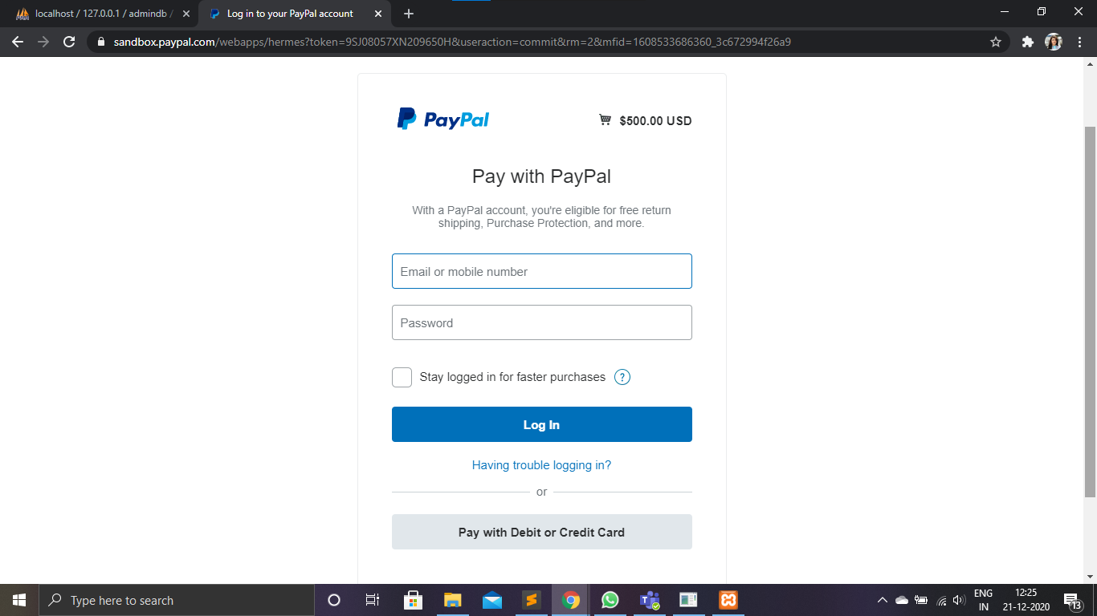

*Fig 58: Paypal payment gateway*

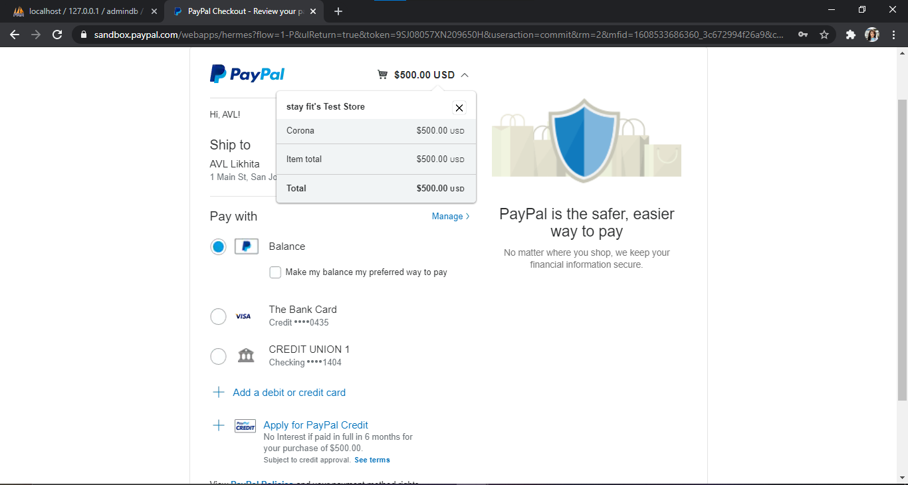

*Fig 59: Cart (plans)*

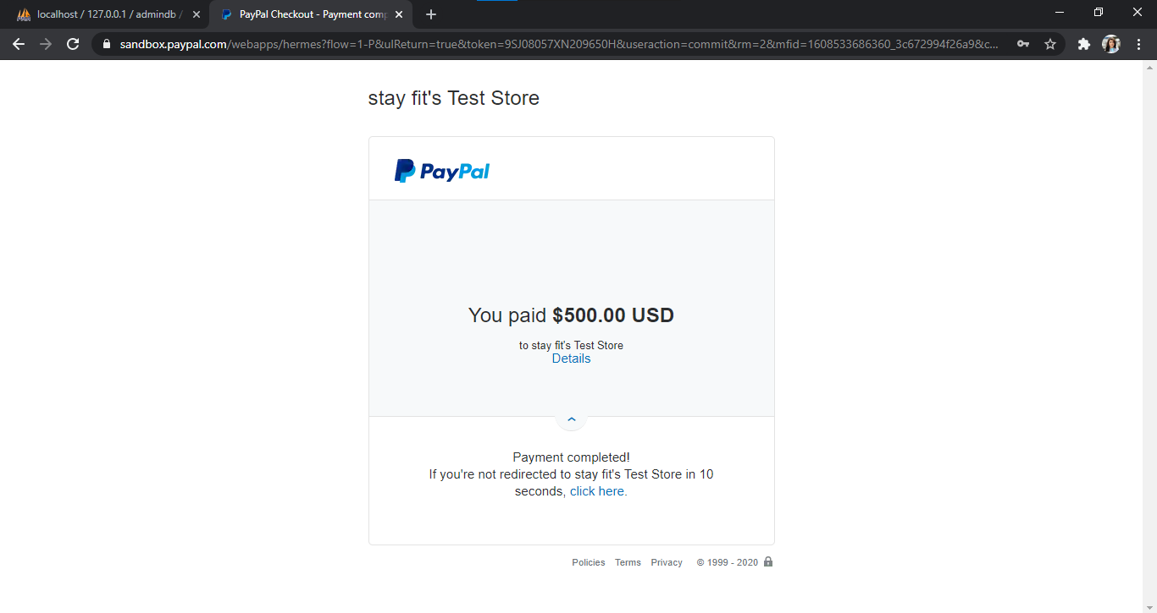

*Fig 60: Payment successful*

**8. SYSTEM TESTING**

System testing is a level of testing that validates the complete and fully integrated

software product. The purpose of a system test is to evaluate the end-to-end system

specifications.

Our project has undergone two levels of testing.

**8.1 Unit Testing**

Unit testing is undertaken when a module has been created and successfully reviewed.

Unit testing was done on every module present in our application.

**1. Test for Admin Module:** Admin is able toadd, delete and modify all workout and food recommendations, subscription plans and tutorials without any error and delay.

Necessary validations were implemented to prevent SQL injection.

**2. Test for Exercise Module:** User is able to add sets. Graphs and muscular visualisations are shown perfectly. Duration time, intensity and volume calculations are accurate.Necessary validations were implemented to preventSQL injection.

**3. Test for Recommendation’s Module:** User is able toget recommendations (food and workouts) according to his/her weight without any errors.

**4. Test for Chat Module:** User is able to clarify the doubts with the bot. String matching is working well without any exceptions.

**8.2 Integration Testing**

In this type of testing, we test various integration of the project module by providing

the input. The primary objective is to test the module interfaces to ensure that no

errors are occurring when one module invokes the other module.

All the changes by admin module, is being reflected in user and chat module. Therefore,

The system can integrate flawlessly and function well.

**9. CONCLUSION & FUTURE WORK**

STAY FIT web application hence acts as an ultimate fitness tracker for the users who wants to keep track of their daily or weekly progress of workouts like their intensity, number of sets, number of reps, time duration etc...For the beginners who are new to any form of workouts will have a separate portal where they can select their plans and workout accordingly. Staying fit does not only mean doing workouts, it must also include a proper diet. This web application also provides a diet (Breakfast,Lunch and Dinner)based on the user's weight.

This project helped us to gain insight into full stack web application development and learn a new framework that is JavaScript. It also helped us to improve our knowledge regarding JavaScript language and HTML scripting.

The website can be further extended to an app in the future as a part of development of our project. Moreover additional functionalities can be added like online training sessions and monthly/yearly food subscriptions of your diet delivered to the user.

**10. REFERENCES**

**For exercise portal:**

[1]BrewerColor Schemes available at <http://www.graphviz.org/doc/info/colors.html>

[2]How can I get query string values in JavaScript? <http://stackoverflow.com/a/2880929/952123>

[3]Filtering disables, <https://github.com/dc-js/dc.js/issues/991>

[4]Justify buttons with Bootstrap v4, <http://stackoverflow.com/questions/34450586>

[5]JavascriptDate.toJSON don't get the timezone offset, <https://stackoverflow.com/questions/11382606/javascript-date-tojson-dont-get-the-timezone-offset>

[6]GitHub Commit Calendar Clone using D3, <https://bl.ocks.org/peterbsmith2/a37f2b733a75a6f348c2>

[7]Add days to JavaScript Date, <https://stackoverflow.com/questions/563406/add-days-to-javascript-date>

[8]For all the sets of exercises, <https://exrx.net/>

**For recommendations portal:**

[9]Integratingpaypal (payment gateway), <https://developer.paypal.com/docs/integration/web/>

[10]<https://www.youtube.com/watch?v=rFSVoGRXcCY>

[11] Paypal home, <https://www.paypal.com/us/home>

[12]Signup for paypal, <https://www.paypal.com/us/signin>

[13] Temporary hosting of a page to redirect from paypal using ngrok, <https://ngrok.com/docs>

[14]Bootstrap alerts, <https://demos.creative-tim.com/argon-dashboard/docs/components/alerts.html>

<https://mdbootstrap.com/docs/jquery/modals/additional/>

**Icons:**

[15]Feather icons: <https://feathericons.com/>

[16]Font awesome : <https://fontawesome.com/> (fas)

<https://fontawesome.com/icons/desktop>(fa)

[17]Regex for strong password, <https://stackoverflow.com/questions/8141125/regex-for-password-php>

[18] Selection of colors, <https://encycolorpedia.com/>

[19]downloading gifs : <https://exrx.net/>

[20]screen recording : <https://www.freescreenrecording.com/>

[21]convert to gifs : <https://ezgif.com/video-to-gif>

[22]resize and compress : <https://compress-or-die.com/gif>

**Food images:**

[23]<http://google.co.in>

[24]<https://pixabay.com/>

[25]<https://www.pexels.com/>

**Tutorial videos:**

[26]<https://www.youtube.com/watch?v=QBxKlqGgb8o>

[27]<https://www.youtube.com/watch?v=ml6cT4AZdqI>

[28]<https://www.youtube.com/watch?v=HRkNfdlm5Qs>

[29]<https://www.youtube.com/watch?v=BHY0FxzoKZE>

[30]<https://www.youtube.com/watch?v=oc4QS2USKmk>

[31]<https://www.youtube.com/watch?v=8MAtXXXUvqo>

**Google fonts**

[32]<https://fonts.google.com/specimen/Poppins>

[33]<https://fonts.google.com/specimen/Ubuntu>

[34]Queries related to css/bootstrap/html : <https://www.w3schools.com/>

[35]Queries related to js, <https://www.tutorialspoint.com/index.htm>

[36]Sql queries and php, <https://stackoverflow.com/>

[37]Table template, <https://www.w3schools.com/css/css_table.asp>

**Github repository:**

[38] Repo: <https://github.com/likhitaavl2k/Stay-fit--A-web-application-which-tracks-your-fitness.git>